1. GraphQL in Practice
2. Location to put graphql schema files

1. Create a graphql query file :query.graphqls. This file defines all the queries, available in graphql server . Here we are creating query for bankAccount

1. Now since BankAccount is not there it is shown as red. Lets go ahead and create Bankaccount type. In bankAccount.graphqls all the banking related queries will be there.
2. Bankaccoutn will have id, name, currency associated with it.

1. We will create another type Currency of type Enum , which lists all the currencies

1. Create our resolver file . Resolver is the file which serves the requests from the bankaccount
2. We Create BankAccountResolver and mark with @Component. This class will be implementing GraphQLQueryResolver and QueryResolver. The difference is : if it is a root query – GraphQLQueryResolver is needed. IF it is nested elements we use GraphQLResolver.
3. Inside BankAccountResolver, wei will add details to accept the BankAccount details and also we will create BankAccount POJO

* Bank Account Class:

* Currency Class:Currency and bankAccount should match the graphqls elements. Note that BankAccount class has @Builder annotation

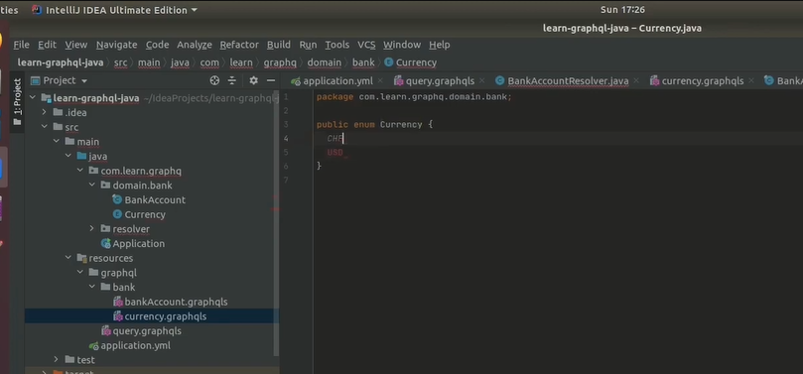

* Now we have the resolver which should resolve BankAccount
* Graphql.playground dependency helps : GraphQL Playground is **a graphical, interactive, in-browser GraphQL IDE**, created by Prisma and based on GraphiQL. In development, Apollo Server enables GraphQL Playground on the same URL as the GraphQL server itself (e.g.

* Now if we run the application . we can see the schema in playground

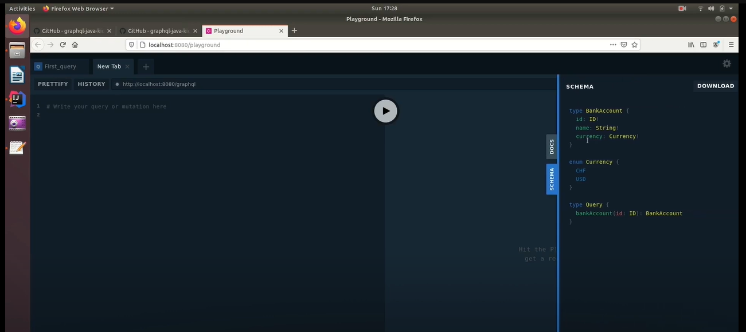

* Docs of playground

* Now if we post the query: using UUID, we get the below response

* Now if we want only currency we can request for that also:

1. Max Depth Limit:

maxQueryDepth: 5

* It is the maximum depth you can have, when you are making a query.
* Even if you don’t have recursion better to set maxQueryDepth

1. **Specifying Auth:**

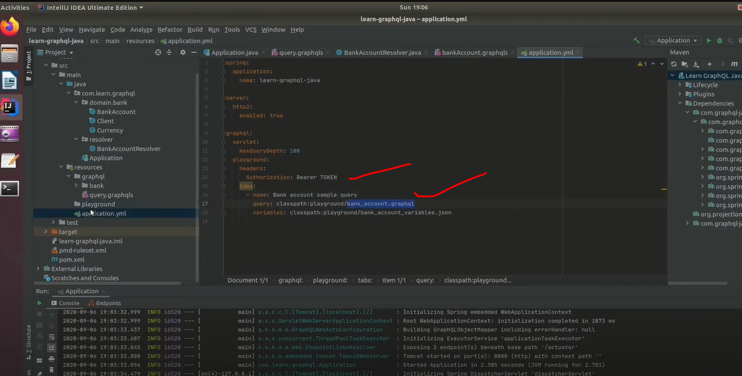

1. Method with argument and its variables:

Variables: Variables are in key value pairs

* In the application:

1. **Voyager: Schema visualizer**

Disabling Voyager:

